Active2Public Transport  
Assessment of User Needs: Transnational online survey on cycling tourism in the Danube Region

Ein Bild, das Transport, Person, Landfahrzeug, Schuhwerk enthält.
Ein Bild, das draußen, Text, Himmel, Gebäude enthält.
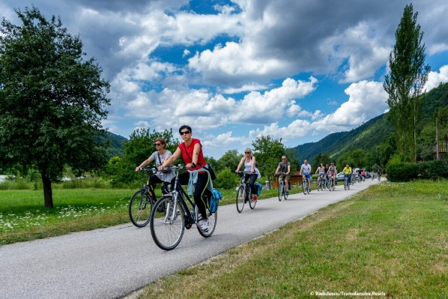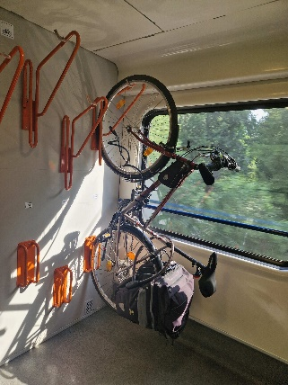

European Cyclists’ Federation

Authors: Holger Haubold, Agathe Daudibon

Version: 1.0

https://interreg-danube.eu/projects/active2public-transport

Active2Public Transport | Better combining cycling, walking and public transport in the Danube Region

https://interreg-danube.eu/projects/active2public-transport

Contact

Coordinator:



Österreichische Energieagentur – Austrian Energy Agency

Irene Bittner

Email Address: [irene.bittner@energyagency.at](mailto:irene.bittner@energyagency.at)

Web: [www.energyagency.at](http://www.energyagency.at)

Authors: Holger Haubold, Agathe Daudibon

Email Address: [h.haubold@ecf.com](mailto:h.haubold@ecf.com)

Web: [www.ecf.com](http://www.ecf.com)

Ein Bild, das Text, Schrift, Grafiken, Logo enthält.
Co-Author: Danube Office Ulm/Neu-Ulm gGmbH

Simone Burster, Annika Morath

Email Addresses:

[s.burster@donaubuero.de](mailto:s.burster@donaubuero.de) ; a.morath@donaubuero.de

Web: [www.donaubuero.de](http://www.donaubuero.de)

More information about Active2Public Transport   
and the project activities & results are available on:

<https://interreg-danube.eu/projects/active2public-transport>

**Table of contents**

Executive Summary 7

Recommendations 10

1 Introduction 15

1.1 Background 15

1.2 Methodology 15

1.3 How to read this report? 17

2 The survey sample 18

2.1 Geographic Distribution 18

2.2 Demographics of the sample 20

2.3 Cycling behaviour in the sample 24

2.4 Behaviour regarding cycling holidays 26

3 Preferences regarding cycling holidays 28

3.1 Reasons for going on a cycling holiday 28

3.2 Most frequently named destinations 30

3.3 Duration of cycling holidays 31

3.4 Planning of cycling holidays 32

3.5 Preferred route types 36

3.6 Bicycles used 37

3.7 Importance of specific criteria for cycling holidays 38

3.8 Satisfaction with cycling holidays 39

3.9 Influence of cycling holidays on everyday cycling 40

4 Focus on public transport – use and satisfaction 42

4.1 Use of public transport 42

4.1.1 Modes of public transport used 42

4.1.2 Criteria for choosing modes of transport 43

4.1.3 Bike transportation on public transport 44

4.1.4 Information sources on public transport 44

4.2 Satisfaction with Public Transport 48

4.2.1 Overall satisfaction with key aspects 48

4.2.2 Satisfaction with specific aspects of public transport stops 50

**Table of figures**

Figure 1: Target groups of the survey 16

Figure 2: Number of answers collected in the project countries per 100,000 inhabitants 19

Figure 3: Gender distribution: Full sample 21

Figure 4: Age distribution EU-27 21

Figure 5: Age distribution full sample 21

Figure 6: Age distributions in different sub-samples 23

Figure 7: Cycling frequency in the general EU-28 population, 2013 24

Figure 8: Cycling frequency in the sample 24

Figure 9: Types of cycling behaviour among respondents in the sample 25

Figure 10: Reasons for going on a cycling holiday: Visitors of Danube Region 29

Figure 11: Reasons for going on a cycling holiday: Cycling holidays outside of Danube Region 30

Figure 12: Most frequently named destinations of last cycling holiday (absolute values, full sample) 31

Figure 13: Information sources for planning cycling holidays (full sample) 33

Figure 14: Information sources on cycling holidays, aggregated for age groups (full sample) 34

Figure 15: Mobile applications used for planning cycling holidays: Visitors of Danube Region 35

Figure 16: Mobile applications used for planning cycling holidays: Cycling holidays outside of Danube Region 35

Figure 17: Preferred route types: Visitors of Danube Region 37

Figure 18: Preferred route types: Cycling holidays outside of Danube Region 37

Figure 19: Satisfaction with specific aspects of last cycling holiday (scale from 1 – not satisfied at all to 5 – extremely satisfied) 40

Figure 20: Relation between cycling holidays and everyday cycling behaviour 41

Figure 21: Modes of transport used for reaching/departing start/end point of cycling holidays 43

Figure 22: Sources of information on public transport to plan journey to/from starting/end point of cycling holiday 45

Figure 23: Information sources on public transport for journey to/from starting/end point of cycling holidays, aggregated according to age groups 46

Figure 24: Information sources on public transport during cycling holiday 47

Figure 25: Information sources on public transport during cycling holiday, aggregated according to age groups 47

Figure 26: Satisfaction with availability of public transport according to destination of last cycling holiday 49

Figure 27: Satisfaction with specific aspects of public transport stops (scale from 1 – not satisfied at all to 5 – extremely satisfied) 51

Table 1: Project countries as countries of residence and destination of last cycling holiday, absolute figures 20

Table 2: Gender distribution among respondents from project countries 22

Table 3: Age distribution among respondents from project countries 22

Table 4: Cycling frequency among respondents in project countries 25

Table 5: Types of cycling behaviour in the project countries 26

Table 6: Share of respondents having been on a cycling holiday already in project countries 27

Table 7: Average and median duration of last cycling holiday 32

Table 8: Use of own bikes and electric bikes during the last cycling holiday 38

Table 9: Importance of specific criteria for cycling holidays (scale from 1 – not important at all to 5 – very important) 39

Table 10: Importance of specific criteria when choosing modes of transport (scale from 1 – not important at all to 5 – very important) 44

Table 11: 5 main areas needing improvement (out of 13) 50

# Executive Summary

The survey within the A2PT project

The current report is part of activity 1.4 “Needs Assessment” of the Interreg Danube Region project “Active2Public Transport” (A2PT). To get a better picture of the needs and obstacles of cycling tourists in the Danube Region, the project has foreseen a transnational quantitative online survey focusing on cycling tourists, with the combination of cycling tourism with public transport as a key aspect. The survey was planned and carried out in the form of a non-representative online survey from 18 September to 29 October 2024 in 13 languages and disseminated through a variety of transnational and national channels.

The survey sample

**Overall, this first-of-its-kind transnational study showed that online surveys are a good way to collect a large number of responses from cyclists, with the important bias of not being representative of the general population. Close attention should therefore be given to comparing results with other (representative) sources and not overinterpreting results.**

* 5,053 complete responses were collected during the survey period.
* 76% of respondents come from the project countries in the Danube region.
* There is a clear overrepresentation of male respondents and middle age groups (25-64 years) compared to the overall population, in line with other, representative surveys on cycling practices.
* Compared to the general population, regular and occasional cyclists are overrepresented in the sample, which is line with the targeting strategy.
* A majority of respondents has experience with cycling holidays; 50% have already been on a cycling holiday in the Danube region.

Preferences regarding cycling holidays

**The survey sample includes an overwhelming majority of respondents who were satisfied with their cycling holiday experience. The main motivations in cycling tourism are being active and experiencing a destination, showing that there is an opportunity for public transport to be part of a positive vacation experience.**

* Respondents in the sample named experiencing more of a destination, being active and exploring routes only accessible by bike as the most important reasons for going on a cycling holiday.
* Compared to other surveys, the duration of cycling holidays in the sample is longer.
* For planning cycling holidays, respondents largely favoured online information sources. However, for older age groups, offline sources still maintain some relative importance as well. When it comes to the use of mobile applications, large commercial transnational applications are more popular than regional ones.
* Respondents in our sample showed a high preference for linear routes (different start and end points of a cycling holiday) compared to other surveys.
* A large majority of respondents used their own bike on cycling holidays; almost 1 out of 5 visitors of Danube Region used an e-bike.
* When planning their cycling holidays, the most important criteria for visitors of the Danube Region were cycling infrastructure, possibility to carry bicycles on public transport, cycling-friendly services and accessibility by public transport.
* Respondents in our sample were overall highly satisfied with their cycling holidays (grade 4.6/%); 96% of respondents would go on a cycling holiday again.

Use of public transport and user satisfaction

**The survey results show a high demand for combining cycling holidays with public transport, and especially for bicycle carriage on public transport vehicles. This indicates that improvements in public transport offers are needed for an increase in satisfaction and usage.**

* A high share of respondents in the sample used public transport, and especially railways, to travel to and from their cycling holiday destination. 35% of all respondents stated that they used public transport also during their cycling holiday (apart from the journey to the start/end point).
* Price, duration of the journey, and convenience/comfort are equally important criteria for respondents when choosing their mode of transport for travelling to/from their destination.
* 75% of public transport users in the survey carried their bike on public transport.
* For information sources on public transport, online sources largely predominate; for older generations, offline sources like information desks, ticket counters are still a bit more important.
* Satisfaction with public transport-related aspects in the sample is relatively low compared to overall satisfaction with cycling holidays:
  + Overall experience with public transport stations: 3.3/5
  + Taking one’s bike on public transport: 3.5/5
  + Use of digital tools for planning public transport journeys: 4.0/5 for journeys to/from the destination of the cycling holiday, 4.1/5 for journeys during the cycling holiday
* After cycling infrastructure, capacity for bicycle transport in trains/buses and cycling-friendly public transport connections were the most named answers for areas where respondents see the most need for improvement.
* When asked about their satisfaction with specific aspects of public transport stops, capacity for bicycle transport on trains/buses and availability of secure bike parking at stations were rated particularly low by respondents.

# Recommendations

Based on the results of the non-representative online survey, we can give the following main recommendations on cycling tourism and its combination with public transport in the Danube Region:

1. Develop cycling tourism in the Danube Region further to benefit from its high potential

In general, there seems to be a lot of potential for cycling tourism in the Danube Region and in the project countries, considering the number of answers collected through the online survey, translated in 13 languages, and distributed through partners and associated partners’ organic communication channels. Small targeted paid campaigns also supported collecting additional answers in the Danube countries where it was needed. 76% of the respondents were from the Danube countries, showing interest from the project region itself. 24% of answers came from outside the area, showing additional global interest from respondents to share their views in our survey focusing on cycling tourism in the Danube Region.

The survey points towards different levels of development in cycling and cycling tourism within the Danube Region. At least for our non-representative sample, cycling tourism is much more developed and mainstream in Germany and Austria then in Romania or Serbia, including for inhabitants who practice other types of cycling. For example, only 37% of Romanian respondents stated that they practice cycle tourism, while cycling for leisure and sport tourism is much more widespread (72% and 62% respectively). German respondents indicated similar levels for sports and leisure cycling, but much higher levels of cycling for tourism (tourism: 69%, leisure: 82%, sport: 66%).  This indicates a large potential development of developing cycling tourism for domestic audiences and foreign visitors alike in the South-Eastern part of the region, and could also be linked to the important investments and long-lasting efforts in developing high quality cycling tourism offers and cycle routes over the years in countries like Germany or Austria, that has most probably also had an important impact on the demand.

This being said, the whole Danube Region is a very high potential cycling tourism destination for multiple reasons. First, because of the Danube River itself, being one of the oldest and most famous cycling tourism destination in the world. Second because of the long-distance cycle route, EuroVelo 6, which follows the Danube for a very long stretch, and is already quite known. For example, [EuroVelo 6 was the 3rd most popular EuroVelo route on the website EuroVelo.com in 2023.](https://eurovelo.com/download/document/EuroVelo-DigitalStats2023-report.pdf) The Danube Cycle Route itself is also very attractive, as it is the 4th favourite route in Germany for German cycling tourists according to the [ADFC Bicycle Travel Analysis 2024.](https://www.adfc.de/fileadmin/BV/RFS/user_upload/Praesentation_Radreiseanalyse2024_en.pdf) And last but not least, the Danube is most often quoted as the favourite cycling destination by Cycling Tour Operators in the [State of Cycling Tour Operators Industry (2024)](https://pro.eurovelo.com/download/document/2024-CyclingTourOp-report.pdf) report.

Considering the high satisfaction of cycling tourists in our survey (4.6 out of 5) and also the facts that 96% of respondents would go on a cycling holiday again, there is huge potential to develop cycling tourism more in the Danube Region. The potential lies in current cycling tourists continuing to go on cycling holidays, but also in convincing new users to start doing the same with quality cycling tourism offers including public transport connections. This would be both for international and domestic cycling tourists.

The potential is even more relevant when considering the benefits for the region crossed by cycling tourists as they are spending generally more than regular tourists and generate direct impact to the local economies. German cycling tourists spend in average 117€ per day for longer cycling trip according to the ADFC Bicycle Travel Analysis. In our survey, only 11% of respondents (and 8% of those visiting the Danube Region) stated ‘travelling budget-friendly” as a reason for going on a cycling holiday.

Cycling tourism can benefit many types of areas and can also be an important opportunity for lesser known and developing destinations. Our respondents are going on cycling holidays mainly as they wish to be active (65%) but also for seeing and experiencing more of a destination (64%). Interestingly, respondents also choose "exploring routes and landscapes only accessible by bike" (53%) as one of the main reasons to choose cycling holiday. This underlines the relevance of investing in new cycling products and/or cycle routes to develop sustainable tourism in lagging or underdeveloped areas.

1. Increase the quality of cycling infrastructure in the Danube Region to support the growth of cycling tourism, including close to public transport hubs

Cycling infrastructure is an aspect consistently rated high by respondents in the sample, both in terms of importance for their cycling holiday (highest importance of all criteria, with 4.2 out of maximum 5 for visitors of the Danube Region) and in terms of areas needing improvement in connection with public transport and signage of bicycle routes. These results indicate that in order to use the potential of cycling tourism, more investments in this area will be quintessential to secure high quality cycle routes in terms of infrastructure and signage.

We can assume that the availability of cycling infrastructure plays an important role in both planning a destination for a cycling holiday as well as for the general satisfaction about the cycling holiday.

In order to take the most advantage of cycling tourism’s potential growth and positive impacts, we recommend to particularly take good care in planning connected cross-border cycle route networks, well-articulated with public transport hubs. Guidelines from the [Danube Cycle Plan](https://dtp.interreg-danube.eu/approved-projects/danube-cycle-plans) project can be implemented for that purpose as well as [EuroVelo Development Guide](https://pro.eurovelo.com/download/document/EuroVelo-Development-Guide_Final.pdf)’s recommendations and the use of the methodology to assess the quality of long-distance cycle routes, [European Certifications Standard](https://pro.eurovelo.com/projects/european-certification-standard) for both the management and planning phase of a cycle route network.

1. Improve the cycle friendliness of public transport connections to increase the use of cycling tourism

Many respondents to our survey used public transport, and especially railways to reach or depart from the start/end point of their cycling holiday, from or outside the Danube Region (59%). While our sample is not representative of the general population, this does show the importance of good public transport connections for cycling tourists. This is especially true for those choosing linear holidays with a different start and end point, for example along a river like the Danube, which is the most popular form of cycling tourism in our sample.

Arriving and departing a destination may involve using long-distance train services with a bicycle, which is a pain point of the combination of bike and train according to ECF’s report “[Cyclists Love Trains](https://www.ecf.com/media/resources/2021/Cyclists_love_trains_report-2.pdf)”, last published in 2021. Also in our survey sample, poor options to arrive and depart by bike to the destination is the second main reason why respondents have not been on a cycling holiday yet. This shows the potential of developing high-quality public transport connections for cycling tourists to visit a destination. The Danube Region would benefit from better long-distance train connections with cycling-friendly offers via high-speed trains or night-trains for example.

They were also many respondents using public transport during their holiday, even though more outside the Danube Region (40%) than inside (27%). Public transport options during the cycling holiday are also an opportunity to spread the flows of cycling tourists even more in the region and prevent overtourism.

Respondents in our survey ranked “cycling-friendly public transport connections” as the 4th most important area needing improvement out of 13 and give a considerably lower grade for public transport-related aspects than for overall satisfaction with their cycling holidays. In an area like the Danube Region with many national borders, improving cross-border public transport services might be particularly relevant. Missing or difficult connections across borders may complicate the experience of cycling tourists even more and require specific attention from public transport managers in order to avoid barriers for cyclists to choose sustainable transport options. Efforts have to be prioritised on simplifying regulation rules across borders, facilitate ticketing, providing information in different languages, coordinating efforts in increasing the number and quality of cycling-friendly offers across borders, and improving cycling-friendliness of public transport stations.

1. Provide sufficient capacity for carrying bicycles on public transport (especially trains and busses)

Carrying bicycles on public transport (especially trains and busses) is crucial for the success of cycling tourism in combination with public transport in the Danube Region. Many respondents in our survey carried their bicycles on public transport (71% in the Danube Region, less than outside, 80%), but with lower satisfaction than for other aspects (close to 2.5/5 for “capacity for bicycle transport on trains/busses” in satisfaction with specific aspects of PT stops, and 3.5/5 on taking one’s bike on public transport in the overall satisfaction). It is also the second most important area needing improvement according to our respondents (capacity for bicycle transport in trains/busses), showing the high-level of priority to address the capacity for carrying bicycles on public transport.

As many cycling tourists prefer to use their own bicycle during their cycling trip (90% of our respondents spending their last cycling holiday in the Danube Region have been using their own bicycle), this requires options to carry bicycles to make public transport attractive and easy to use for cycling tourists.

Different solutions can be explored to properly address the bicycle carriage offer for cycling tourism, such as seasonal offers with adapted rolling stock increasing temporarily the capacity to carry bicycles, or strategies to anticipate the flows of tourists to facilitate the management at station and optimisation of available spaces.

If bicycle carriage cannot be increased, second-best alternatives can be sought by developing parallel transport options for bicycles with one way transport for example, or bicycle rental can be encouraged with sufficient volume and quality offers to answer all potential needs.

1. Improve online information on cycling tourism and public transport, including for international audiences

The results of our survey show the large predominance of online information sources among respondents in the sample, be it for planning cycling holidays in general, planning the journey on public transport to and from the destination, or getting information on public transport during the trip.

General public transport websites or other communication tools should provide information answering the specific needs of cycling tourists, for example with dedicated pages. Providing information on public transport, bicycle carriage etc. in multiple languages (at the very least the local language and English) should be considered as well to accommodate the needs from international cycling tourists looking for information. Communication and information should also be adapted to the seasonality of cycle tourism demand. Public transport companies could also invest in communication campaigns to attract more users to their bike and train offers.

When asked about which applications they used for planning their trip, popular global applications like Google Maps were quoted most often by respondents, much more than regional apps of tourist boards for example. That could be an indication that it makes more sense to invest in providing high-quality and up-to-date data on cycling infrastructure, services along the routes, public transport connections etc. to these global applications than for each region to develop their own mobile applications.

# Introduction

## Background

The current report is part of activity 1.4 “Needs Assessment” of the Interreg Danube Region project “Active2Public Transport” (A2PT). The A2PT project aims to reduce CO2 emissions in the transport sector in the Danube Region by improving the link between active and zero-emission forms of mobility such as cycling and walking and public transport such as bus and train. The activity on needs assessment starts from the assumption that cyclists’ and pedestrians’ needs should be the basis for any action to improve the current conditions regarding A2PT.

To get a better picture of the needs and obstacles of cycling tourists in the Danube Region, the project has foreseen a transnational quantitative online survey focusing on cycling tourists, while also integrating the feedback of leisure cyclists who have not been on a cycling holiday yet. The key aspect is the combination of cycling tourism with public transport. The results of the survey are used to give an overview of the current conditions regarding cycling tourism in the Danube Region and to elaborate recommendations to improve the situation, especially in combining cycling with public transport. These recommendations are meant to become an integral part of the Danube A2PT Action Plan.

## Methodology

The survey was planned and carried out in the form of a non-representative online survey by the European Cyclists’ Federation (ECF) which was contracted by the A2PT project partner Danube Office Ulm/Neu-Ulm. The conception phase of the survey was further informed by the expertise and feedback of the other A2PT project partners as well as interested members of the ECF’s network of National EuroVelo Coordination Centres.

The survey mainly targeted regular cyclists, and especially those who have been on a cycling holiday already. The target group of the survey included both residents of the Danube Region and cyclists living outside of that region. The aim was to reach a sufficiently big number of respondents who had been on a cycling holiday in the Danube Region already, but also those who had gone on a cycling holiday outside of the region for comparison.

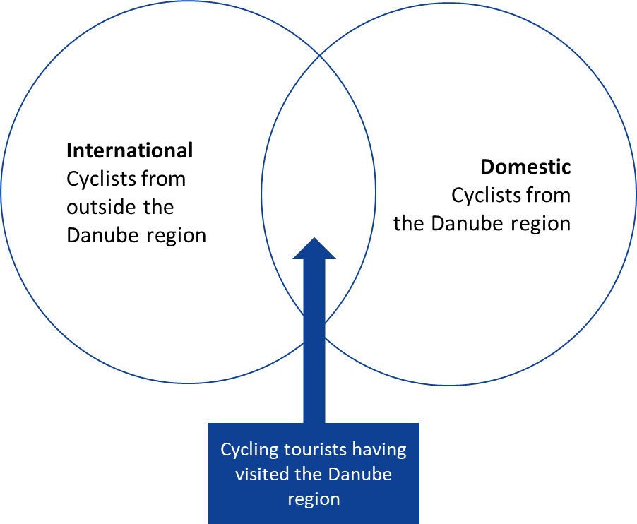

Figure 1: Target groups of the survey

The survey was conducted was from 18 September to 29 October 2024 on the professional online survey platform QuestionPro. The survey contained 57 questions in total; however, the actual number of questions respondents had to answer depended on their answers to specific guiding questions on cycling behaviour, public transport use etc. The initial estimate for the time to complete the survey was approximately 10 minutes.

The questions of the survey were drafted in English and then translated into 13 languages of the Danube Region and beyond:

* Bulgarian
* Croatian
* Czech
* Dutch
* French
* German
* Hungarian
* Italian
* Romanian
* Serbian
* Slovak
* Slovenian
* Spanish

The survey was disseminated through a variety of transnational and national channels. Transnational channels, besides the ones of the A2PT project and its partners, were above all the EuroVelo communication channels (social media, EuroVelo website, newsletters and mailings), with support from the general ECF communication channels. National channels, besides those of several National EuroVelo Coordination Centres, were mainly those of the A2PT project partners: social media (LinkedIn, Facebook, Instagram), newsletters, events, websites and other. During the end of the survey period, a paid ad campaign on social media was carried out, targeted at project countries where not enough answers had been received yet.

## How to read this report?

This report analyses and synthesises the main learnings from the online survey targeting cycling tourists in the Danube Region and asking them to comment on their experience involving public transport. The sample reached by the online survey does not represent the general population but collects a large number of answers from different countries and different profiles of respondents. Based on the feedback from users, this report elaborates recommendations for the partners of the A2PT project in the Danube Region to improve the conditions for cyclists in combination with public transport and in general. It also constitutes a useful pilot project on the use of online survey for European-wide needs assessment of cyclists.

# The survey sample

**5,053 complete responses** were collected during the survey period, out of 7,584 responses in total. The following analysis will only focus on the complete responses. There is no comparison possible on the number of complete answers collected as this was the first attempt to establish a European wide online survey of cycling tourists, translated in different languages and established by ECF as coordinator of EuroVelo. As a point of reference, the German cyclists’ association ADFC has been leading a well-established public online survey on cycling tourism, the “Bicycle Travel Analysis” for more than 20 years now, which is distributed its through its members and communication channels and received 13,685 responses for the 2023 edition. Given that the present survey was carried out for the first time and included regions where cycling tourism is not as well developed as in Germany, the number of responses seems proportionate taking into account these factors.

As stated in the section above on target groups of the survey, the results that are presented in this report are based on a **non-representative sample** focusing on regular cyclists and people having experience with cycling holidays. This means that they are not representative of the experiences and opinions of the population as a whole. They do, however, give valuable insights into the experiences and opinions of a sample of respondents having an interest in cycling and cycling holidays. This means that to interpret the results of the survey, it is important to first describe the composition of this sample.

## Geographic Distribution

76% of respondents come from the project countries in the Danube Region

The focus on the project countries regarding the national dissemination channels is reflected in the geographic distribution of the sample: 75.8% of respondents stated that they lived in one of the project countries (Austria, Croatia, Czechia, Germany, Hungary, Romania, Serbia, Slovakia, Slovenia; for Germany: only the states of the Danube Region, Bavaria and Baden-Württemberg). The two countries with more than 100 respondents outside of the project region were the United Kingdom and France. Approximately . 4% of respondents stated that they lived in a country outside Europe.

The graph below shows the response frequency for the project countries relative to their population (for Germany: only responses and population from Bavaria and Baden-Württemberg).

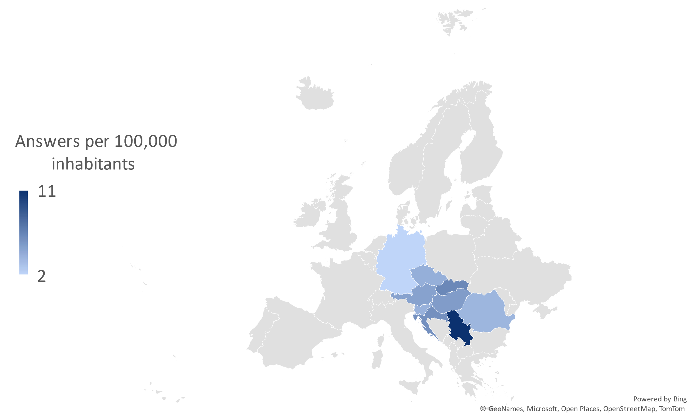

Figure 2: Number of answers collected in the project countries per 100,000 inhabitants

|  |  |  |
| --- | --- | --- |
| Project country | Respondents living in project country | Respondents indicating project country as destination of last cycling holiday |
| Austria | 425 | 940 |
| Croatia | 216 | 297 |
| Czechia | 429 | 386 |
| Germany (only BY+BW) | 471 | 525 |
| Hungary | 477 | 506 |
| Romania | 684 | 344 |
| Serbia | 718 | 244 |
| Slovakia | 329 | 335 |
| Slovenia | 81 | 258 |

Table 1: Project countries as countries of residence and destination of last cycling holiday, absolute figures

## Demographics of the sample

Overrepresentation of male respondents and middle age groups (25-64 years)

Looking at the demographics of the sample, there is a clear overrepresentation of male respondents and middle age groups (25-64 years) compared to the overall population. Regarding the gender distribution, the result reflects data from other, representative surveys on cycling behaviour showing higher cycling levels among the male population. For example, an EU- wide travel survey carried out in 2021 showed a mode share of cycling of 9.2% (trips) for men, but only 6.3% for woman. The age distribution could be linked to the channels through which the survey was most widely disseminated, for example Facebook, which is used relatively less often by the youngest and the oldest age groups. For the oldest age groups, other surveys also show less cycling activity (for example in the EU-wide travel survey mentioned above: cycling mode share of 6.1% for the population 65+ vs. 7.8% for the population as a whole). This could be an additional explaining factor for the underrepresentation of this group in the survey sample.

Figure 3: Gender distribution: Full sample

The tables below shows the gender and age distributions for the project countries. There are large differences in the gender distribution, with representation of female respondents reaching from 27% in Romania to 47% in Austria. When it comes to the age distribution, the largest differences can be found in the representation of the youngest age group (16 – 24 years), with a spread from 2.4% (Slovakia) to 40.7% (Slovenia). The differences in age can probably be explained through the different outreach channels in the respective countries.

Figure 4: Age distribution EU-27

Figure 5: Age distribution full sample

|  |  |  |  |  |  |  |  |  |  |
| --- | --- | --- | --- | --- | --- | --- | --- | --- | --- |
| **Gender** | **DE (BY+BW)** | **AT** | **CZ** | **SK** | **SI** | **HU** | **HR** | **RS** | **RO** |
| **Female** | 40.1% | 47.1% | 39.4% | 35.0% | 45.7% | 33.5% | 44.4% | 34.0% | 27.2% |
| **Male** | 59.2% | 52.0% | 60.4% | 64.7% | 54.3% | 65.8% | 55.6% | 65.9% | 72.7% |
| **Diverse** | 0.6% | 0.9% | 0.2% | 0.3% | 0.0% | 0.6% | 0.0% | 0.1% | 0.2% |

Table 2: Gender distribution among respondents from project countries

|  |  |  |  |  |  |  |  |  |  |
| --- | --- | --- | --- | --- | --- | --- | --- | --- | --- |
| **Age** | **DE (BY+BW)** | **AT** | **CZ** | **SK** | **SI** | **HU** | **HR** | **RS** | **RO** |
| **16 – 24** | 5.1% | 3.3% | 15.2% | 2.4% | 40.7% | 2.9% | 11.1% | 4.3% | 6.6% |
| **25 – 44** | 40.6% | 42.1% | 36.8% | 55.6% | 30.9% | 27.5% | 37.5% | 51.0% | 50.4% |
| **45 – 64** | 40.8% | 48.2% | 41.5% | 37.7% | 24.7% | 61.8% | 48.2% | 41.5% | 41.2% |
| **65 or older** | 13.6% | 6.4% | 6.5% | 4.3% | 3.7% | 7.8% | 3.2% | 3.2% | 1.8% |

Table 3: Age distribution among respondents from project countries

Age distribution: geographical differences

For the analysis of the results, it is also important to note that there is a marked difference in the age composition of the sub-samples:

* Of residents and visitors of the Danube Region (respondents whose last cycling holiday was exclusively in that region) with a large dominance of middle age groups on one hand;
* And residents outside of the Danube Region and people who spent their cycling holiday outside of the Danube Region, with an even lower share of young respondents, and a higher share of older respondents (65+) on the other hand.

Figure 6: Age distributions in different sub-samples

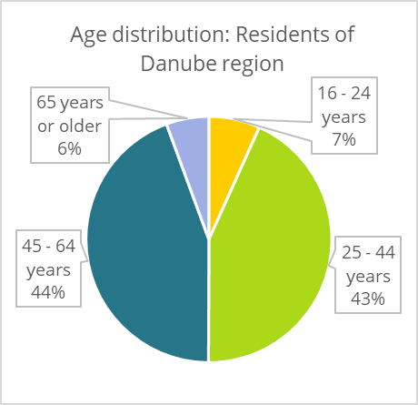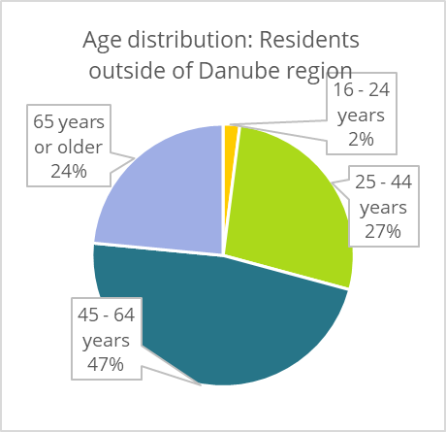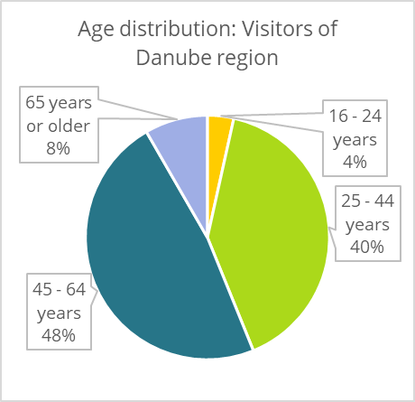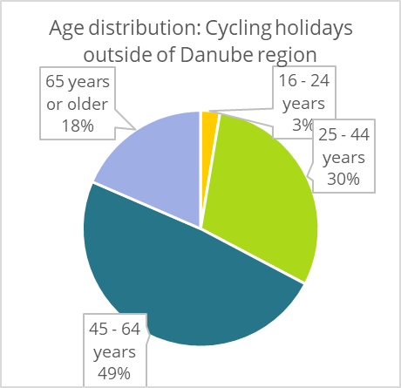

These differences need to be taken into account when interpreting the results below. For example, certain behaviours preferred by a specific age group (such as use of digital vs. offline information tools) could be more prevalent in one sub-sample than in the other because of the differences in age distribution.

## Cycling behaviour in the sample

Overrepresentation of regular and occasional cyclists in the sample compared to the general population

Compared to the general population, the sample consists almost exclusively of people cycling at least occasionally, with a large majority cycling regularly (at least a few times a week). Only 2% of respondents state that they never cycle, which is clearly not representative of the general population. For example, in a representative EU-wide survey carried out in 2013 (Special Eurobarometer 406 on Attitudes of Europeans towards Urban Mobility), 50% of respondents stated that they never cycle.

Figure 7: Cycling frequency in the general EU-28 population, 2013

When respondents were asked how they would characterise their cycling behaviour, the most named types of cycling were leisure, sports and tourism. A bit more than half of the sample cycled for daily transport purposes, and 7% stated that they liked cycling, but do not practise it very often. A large share or respondents used multiple options to describe their cycling behaviour.

Figure 8: Cycling frequency in the sample

Figure 9: Types of cycling behaviour among respondents in the sample

A further disaggregation of the results for the project countries shows important differences. When it comes to the cycling frequency, only 11% of respondents in the Czech sample stated that they cycled at least once a day (Eurobarometer 2013: 7%), compared to 33% in the German sample (Eurobarometer 2013: 19%).

|  |  |  |  |  |  |  |  |  |  |
| --- | --- | --- | --- | --- | --- | --- | --- | --- | --- |
| **How often do you cycle?** | **DE (BY+BW)** | **AT** | **CZ** | **SK** | **SI** | **HU** | **HR** | **RS** | **RO** |
| **At least once a day** | 32.7% | 21.4% | 11.2% | 15.5% | 12.4% | 27.9% | 20.8% | 25.5% | 17.3% |
| **A few times a week** | 54.1% | 56.2% | 48.7% | 53.2% | 25.9% | 49.1% | 38.4% | 48.6% | 49.0% |
| **A few times a month or less often** | 12.3% | 20.1% | 36.1% | 29.8% | 35.8% | 21.8% | 31.9% | 24.1% | 30.0% |
| **Never** | 0.4% | 0.9% | 2.6% | 1.2% | 21.0% | 0.9% | 7.4% | 1.1% | 2.1% |
| **Don’t know** | 0.4% | 0.5% | 1.4% | 0.3% | 4.9% | 0.4% | 1.4% | 0.7% | 1.8% |

Table 4: Cycling frequency among respondents in project countries

Regarding the types of cycling, while a similar proportion of respondents in partner countries described themselves as leisure or sports cyclists, the differences in the other categories were much bigger. This concerns cycling for mobility (variation from 36% in the Romanian sample to 75% in the German sample) and cycling for tourism (variation from 23% in the Serbian sample to 69% in the German sample). The last result is also broadly in line with the results below on behaviour regarding cycling holidays. Just like for the age distribution, the Slovenian sample represents somewhat of an outlier, with 21% of Slovenian respondents stating that they never cycle (frequency), and 27% characterising themselves as “observers” of cycling (type of cycling).

|  |  |  |  |  |  |  |  |  |  |
| --- | --- | --- | --- | --- | --- | --- | --- | --- | --- |
| **Type** | **DE (BY+BW)** | **AT** | **CZ** | **SK** | **SI** | **HU** | **HR** | **RS** | **RO** |
| **Mobility** | 75.3% | 68.4% | 41.9% | 44.6% | 40.6% | 43.8% | 43.5% | 49.7% | 36.0% |
| **Sport** | 65.5% | 67.5% | 63.6% | 66.5% | 54.7% | 65.8% | 60.5% | 51.7% | 61.5% |
| **Leisure** | 81.5% | 73.9% | 68.7% | 77.5% | 64.1% | 77.4% | 66.0% | 72.7% | 71.8% |
| **Tourist** | 68.9% | 66.5% | 49.9% | 39.4% | 48.4% | 40.1% | 33.0% | 22.8% | 36.7% |
| **Observer** | 2.6% | 6.2% | 13.0% | 7.4% | 26.6% | 3.6% | 12.5% | 5.2% | 12.1% |

Table 5: Types of cycling behaviour in the project countries

## Behaviour regarding cycling holidays

A majority of respondents has experience with cycling holidays; 50% have already been on a cycling holiday in the Danube Region.

As with regular cyclists in general, people who have been on a cycling holiday already are most probably also overrepresented in the sample compared to the general population. This could be expected from the outreach strategy and dissemination channels of the online survey. In total, 70% of respondents stated that they have been on a cycling holiday already, with a cycling holiday being defined as cycling holiday a holiday away from home, with at least one overnight stay, which involves cycling as main activity during the holiday.

50% of respondents stated that they have already been on a cycling holiday in the Danube Region. Of those who have been on a cycling holiday already, but not in the Danube Region, **48% stated that they are planning to go to the Danube Region in the future, while 43% stated that they would maybe go or did not know yet.** This gives an indication for the **great potential of further promoting cycling holidays in the Danube Region.**

There are important differences between the national samples of the project countries, with the lowest familiarity with cycling holidays in the Serbian sample (38%) and the highest in the German sample (82%). While the samples are not representative for the population, they are all composed of a large majority of regular and occasional cyclists (with only Slovenia and to a lesser extent Croatia having a higher number of respondents stating that they never cycle). Therefore, the variation in the familiarity with cycling holidays gives at least an indication on how popular cycling holidays are in the cycling population of the project countries.

|  |  |  |  |  |  |  |  |  |  |
| --- | --- | --- | --- | --- | --- | --- | --- | --- | --- |
| **Ever been on a cycling holiday?** | **DE (BY+BW)** | **AT** | **CZ** | **SK** | **SI** | **HU** | **HR** | **RS** | **RO** |
| **Yes** | 81.7% | 81.0% | 80.2% | 60.9% | 46.9% | 77.8% | 45.5% | 37.8% | 56.9% |
| **No** | 18.3% | 19.0% | 19.8% | 39.1% | 53.1% | 22.2% | 54.5% | 62.3% | 43.1% |

Table 6: Share of respondents having been on a cycling holiday already in project countries

# Preferences regarding cycling holidays

## Reasons for going on a cycling holiday

Experiencing more of a destination, being active and exploring routes only accessible by bike most important reasons for going on a cycling holiday

When asked about their reasons for going on a cycling holiday, respondents from the sample most often named:

1. Seeing and experiencing more of your destination (66%)
2. Being active during your holiday (62%)
3. Exploring routes and landscapes only accessible by bike (54%)

These results are broadly in line with a similar question in ADFC’s Bicycle Travel Analysis 2024. Interestingly, only 11% of all respondents and 8% of those visiting the Danube Region named “travelling budget-friendly” as a reason for going on a cycling holiday. This could be an indication of the spending capacity, which is at least equal to that of other types of tourists, and the growing economic potential of this type of tourists for the countries and regions they visit.

Generally, there are only minor differences in the reasons for going on a cycling holiday between respondents who spent their last cycling holiday in the Danube Region and those who did not. For respondents who visited the Danube Region, improving their health is more important than for those outside, while travelling in an environmentally friendly/climate-conscious way is less important.

A category that was not included in the initial list of answering options, but often mentioned by respondents under the “other” option, was spending time with family/friends.

Figure 10: Reasons for going on a cycling holiday: Visitors of Danube Region

Figure 11: Reasons for going on a cycling holiday: Cycling holidays outside of Danube Region

## Most frequently named destinations

Good representation of project countries as cycling holiday destinations in the sample

The graph below shows the most frequently named destinations for the last cycling holiday from the sample. Since the sample is not representative, we cannot draw conclusions on the popularity of the different countries in the general population or among all cycling tourists. However, the analysis shows that the survey has managed to collect a significant number of answers from visitors of all project countries in the Danube Region.

Figure 12: Most frequently named destinations of last cycling holiday (absolute values, full sample)

## Duration of cycling holidays

Duration of cycling holidays in the sample is longer than in other surveys

The average duration of the last cycling holiday for the sample as a whole is 13.5 nights. It is important to note that even after checking for outliers, this average is influenced by a number of very long cycling holidays especially for respondents having spent their cycling holidays outside the Danube Region. The median duration is 6 nights, meaning that 50% of cycling holidays are below and 50% are above this value. Cycling holidays in the Danube Region visitor sample are shorter both on average (6.3 nights) and median (4 nights) than those outside the region (average 17.6 nights, median 9 nights). The values for the Danube Region sample are also much closer to the comparison value of the ADFC Bicycle Travel Analysis 2024, which found an average value of 4.4 nights.

|  |  |  |  |
| --- | --- | --- | --- |
|  | **All answers** | **Visitors of Danube Region** | **Cycling holidays outside Danube Region** |
| **Average** | 13.5 | **6.3** | 17.6 |
| **Median** | 6 | **4** | 9 |

Table 7: Average and median duration of last cycling holiday

## Planning of cycling holidays

Main information sources

Large predominance of online sources

When asked about the main information sources for the planning of cycling holidays, respondents showed a clear preference for online sources in the form of internet research (83%) and mobile applications (40%). Recommendations from family/friends/colleagues etc. also played an important role (31%), even more than recommendations on social media (23%). Offline sources like guidebooks (23%) or tourist information offices (18%) continue to weigh as well, while tour operators (7%), tourism/cycling fairs (4%) or travel agencies (2%) play a relatively minor role.

Figure 13: Information sources for planning cycling holidays (full sample)

The main difference between visitors of the Danube Region and those having spent their last cycling holiday outside the region is the more frequent use of guidebooks for the latter group (29% vs. 17%, giving an average of 23% for the whole sample). This could be explained by the different age profiles of the subsamples. A disaggregation into the different age groups of the sample shows an important variation in the use of guidebooks, which are used much more frequently by older age groups. This could give an indication on a possible decline of this information source in the future.

Figure 14: Information sources on cycling holidays, aggregated for age groups (full sample)

use of mobile applications

Large commercial transnational applications more popular than regional ones

When it comes to the use of mobile applications, large commercial transnational apps clearly dominate the picture among respondents, with Google Maps and Komoot being named the most popular apps. These results are broadly in line with those of the ADFC Bicycle Travel Analysis 2024. For visitors of the Danube Region, the Czech-developed app Mapy.cz, which uses Open Street Map data, is also an important information source. Apps of regional tourist boards and public transport operators only play a relatively minor role,

Figure 15: Mobile applications used for planning cycling holidays: Visitors of Danube Region

Figure 16: Mobile applications used for planning cycling holidays: Cycling holidays outside of Danube Region

## Preferred route types

High share of linear routes compared to other sources

The respondents from the overall sample indicated a preference for linear routes (not coming back to the starting point, changing accommodation; 57%) and for loop-shaped routes (coming back to the starting point at the end of the trip, changing accommodation; 34%) compared to star-shaped routes (coming back to the starting point every day of the trip, not changing accommodation; 22%). This preference is less pronounced for visitors of the Danube Region, where star-shaped routes are more popular and linear routes less popular than for those respondents having spent their last cycling holiday outside the Danube Region.

Compared to other data sources, the sample exhibits a possible overrepresentation of cycle tourists going on linear routes or loop-shaped routes, changing accommodation during their trip. For example, a recent study from Brittanny based on the French EVA-VELO methodology with on-site surveys found that only 17% of cycle tourists were changing accommodation on their trip, whereas 83% stayed in a fixed accommodation. Possible explanations could be the dominance of longer routes along rivers in the Danube Region (with EuroVelo 6 as the main example), as well as the targeting of respondents for the survey, focusing on people with experience of (longer) cycling holidays. Further research including representative samples and/or on-site surveys would be needed to put these results into context. In any case, they highlight the need for good public transport connections with availability of bicycle transport especially for those choosing linear routes with different start and end points.

Figure 17: Preferred route types: Visitors of Danube Region

Figure 18: Preferred route types: Cycling holidays outside of Danube Region

## Bicycles used

Large majority of respondents used their own bike on cycling holidays; almost 1 out of 5 visitors of Danube Region used an e-bike.

When it comes to the use of bicycles during their last cycling holiday, an overwhelming majority of respondents used their own bike, both for those who visited the Danube Region (92%) and those who did not (90%). This points towards the need for adequate provision of bicycle transport on trains and buses, also for example on long-distance trains taking tourists towards their cycling holiday destination.

Electric bikes have an important share in the use of bicycles in the sample, with 19% for visitors of the Danube Region and 17% for those having spent their last cycling holiday outside the Danube Region.

|  |  |  |
| --- | --- | --- |
|  | **Visitors of Danube Region** | **Cycling holidays outside Danube Region** |
| **Own bike** | **91.8%** | 89.5% |
| **Electric bike** | **18.6%** | 16.7% |

Table 8: Use of own bikes and electric bikes during the last cycling holiday

## Importance of specific criteria for cycling holidays

Most important criteria for visitors of Danube Region are cycling infrastructure, possibility to carry bicycles on public transport, cycling-friendly services and accessibility by public transport

When asked to rate the importance of specific criteria for their cycling holidays, respondents gave the highest importance to cycling infrastructure. Public-transport related aspects were also rated high, especially the possibility to carry a bicycle. The offer of cycling-friendly services along the route was also important for respondents. The results give an indication on the focus areas to improve to make cycle tourism more attractive – infrastructure, services and public transport connections. Overall, results were very similar between visitors of the Danube Region and those having spent their last cycling holiday outside the region.

|  |  |  |
| --- | --- | --- |
|  | **Visitors of Danube Region** | **Cycling holidays outside Danube Region** |
| **Dedicated cycling infrastructure available** | **4.24** | 4.13 |
| **Possibility to carry my bicycle on public transport.** | **3.56** | 3.87 |
| **Offer of cycling-friendly services along the route** | **3.38** | 3.26 |
| **Accessibility of the destination by public transport** | **3.27** | 3.63 |
| **Price of the trip** | **3.16** | 3.05 |
| **GPX tracks of the route easily accessible online** | **3.11** | 3.14 |
| **Availability of bike rental services** | **1.97** | 1.95 |
| **Charging options for e-bikes/pedelecs** | **1.91** | 1.84 |

Table 9: Importance of specific criteria for cycling holidays (scale from 1 – not important at all to 5 – very important)

## Satisfaction with cycling holidays

High overall satisfaction with cycling holidays, 96% of respondents would go on a cycling holiday again

The survey results show that respondents in the sample gave a high overall grade for satisfaction with their last cycling holiday. The average grade was 4.6 out of 5, both for visitors of the Danube Region and people who had spent their last cycling holiday outside of that region. What is more, an overwhelming majority of 96% would go on a cycling holiday again.

When asked about the satisfaction with specific aspects of their last cycling holiday, a more mixed picture emerged from respondents in the sample. One particular aspect that might merit more attention in the future is the relative lack of satisfaction with public restrooms along the routes.

Figure 19: Satisfaction with specific aspects of last cycling holiday (scale from 1 – not satisfied at all to 5 – extremely satisfied)

## Influence of cycling holidays on everyday cycling

Influence of cycling holidays on everyday cycling is small in the sample, especially for frequent cyclists.

When asked about the influence of their cycling holiday on everyday cycling behaviour, a large majority of respondents stated that they cycle the same amount after their cycling holiday than before. This could be linked to the fact that most respondents were regular cyclists in any case.

Some differences can be noted however linked to the frequency of everyday cycling: Whereas respondents who cycle every day show a very low influence of cycling holidays on their subsequent cycling behaviour, the share of respondents who report a change grows for people who cycle a few times per week and is even higher for those who cycle only a few times per month. Interestingly, in the last group, more respondents reported that they cycle less after their cycling holidays than before. Further research will be needed to confirm this result, which seems counterintuitive at first instance, and find out more about the reasons behind.

Figure 20: Relation between cycling holidays and everyday cycling behaviour

# Focus on public transport – use and satisfaction

## Use of public transport

### Modes of public transport used

To reach and depart the destination

High share of respondents used public transport, and especially railways

For respondents of the survey, public transport, and especially railways, were an important means of reaching/departing the start/end point of their cycling holidays. For visitors of the Danube Region, the car was also an important mode of transport, more so than for those who spent their last cycling holiday outside the region. The latter group used planes more often to reach/depart their cycling holiday destination. In both groups, almost 30% of respondents stated that they cycled right from the start of their cycling holiday.

Compared to the ADFC Bicycle Travel Analysis focusing on a representative survey of German cycling tourists, our sample shows a higher share of respondents using railways/public transport to reach/depart their destination (59.2% for both together vs. ca. 40% in the ADFC survey for cycling trips with 3+ nights).This difference could be explained by the fact that our targeting through social media and cycling communities focused in particular on respondents having experience with the combination of cycling tourism and public transport.

Figure 21: Modes of transport used for reaching/departing start/end point of cycling holidays

During Cycling HOlidays

35% of all respondents stated that they used public transport also during their cycling holiday (apart from the journey to the start/end point).

For visitors of the Danube Region, this share was lower (27%) than for people who spent their last cycling holiday outside the Danube Region (40%).

### Criteria for choosing modes of transport

Price, duration of the journey, and convenience/comfort are equally important for respondents.

When asked about the importance of specific criteria for choosing modes of transport to reach/depart the destination of their cycling holidays, no clear picture emerged, with three criteria reached almost the same levels of importance:

* Price;
* Duration of the journey;
* Convenience/comfort.

For visitors outside the Danube Region, sustainability came at a close fourth, while this criterion was a bit less important for visitors of the Danube Region. Cancellation options were considered relatively less important by both groups.

|  |  |  |
| --- | --- | --- |
|  | **Visitors of Danube Region** | **Cycling holidays outside Danube Region** |
| **Price** | 3.37 | 3.34 |
| **Duration of the journey** | 3.39 | 3.30 |
| **Convenience/comfort** | 3.39 | 3.36 |
| **Sustainability** | 3.18 | 3.29 |
| **Cancellation option** | 2.94 | 2.67 |

Table 10: Importance of specific criteria when choosing modes of transport (scale from 1 – not important at all to 5 – very important)

### Bike transportation on public transport

75% of public transport users in the survey carried their bike on public transport

One striking result of the survey is that of those respondents who used public transport either to reach/depart their destination and/or during their cycling holiday, 75% carried their bike with them on public transport. For the Danube Region, the share was 71%, and for those who spent their last cycling holiday outside the Danube Region 80%. This result indicates the need to provide sufficient space for transporting bicycles on public transport vehicles like trains to enable a smooth and comfortable combination of cycling holidays with public transport.

### Information sources on public transport

Large predominance of online sources; for older generations, offline sources like information desks, ticket counters are still a bit more important.

To reach and depart the destination

Regarding information sources on public transport for the journey to/from the destination of the cycling holiday, online sources including mobile applications are predominating among respondents in the sample. There are no big differences between visitors of the Danube Region and those having spent their last cycling holiday outside, except for counters at station, which are used more often by the latter group. This could be related to the higher share of older respondents in the group who spent their last cycling holiday outside the Danube Region. In fact, when responses are disaggregated according to age groups, the oldest age group (65+) shows a slightly higher use of offline sources like counters at stations or travel agencies.

Figure 22: Sources of information on public transport to plan journey to/from starting/end point of cycling holiday

Figure 23: Information sources on public transport for journey to/from starting/end point of cycling holidays, aggregated according to age groups.

During Cycling HOlidays

The same picture emerged when respondents were asked which information sources on public transport they used during their cycling holiday. Also in this case, online sources in the form of mobile applications and website were largely dominant both among visitors of the Danube Region and those having spent their cycling holidays outside the region. Offline sources, including ticket machines and other machines (like interactive information screens) were a bit more relevant for the oldest age group (65+), which was also more represented in the sub-sample of respondents having spent their cycling holidays outside the Danube Region. It should be noted that especially the youngest age group (16-24 years) constituted a relatively small sub-sample, so results should be read with caution for this group.

Figure 24: Information sources on public transport during cycling holiday

Figure 25: Information sources on public transport during cycling holiday, aggregated according to age groups

## Satisfaction with Public Transport

### Overall satisfaction with key aspects

Low satisfaction with public transport-related aspects compared to overall satisfaction with cycling holidays

An important finding is that overall satisfaction with key aspects related to public transport is noticeably lower among respondents in the sample than their overall satisfaction with cycling holidays (grade 4.6 out of maximum 5):

* Overall experience with public transport stations: 3.3/5
* Taking one’s bike on public transport: 3.5/5
* Use of digital tools for planning public transport journeys: 4.0/5 for journeys to/from the destination of the cycling holiday, 4.1/5 for journeys during the cycling holiday

This shows that there is a lot of room for improvement in these areas, especially regarding the experience of cycle tourists at public transport stations and the transportation of bicycles on public transport vehicles like trains.

Regarding the availability of public transport, there are important geographic differences. The highest satisfaction rates among respondents were among those who spent their cycling holidays in Switzerland or the Netherlands, countries outside the Danube Region. Within the region, satisfaction rates were noticeably higher in Central European countries than in South-Eastern European countries, showing also the potential for improvement here.

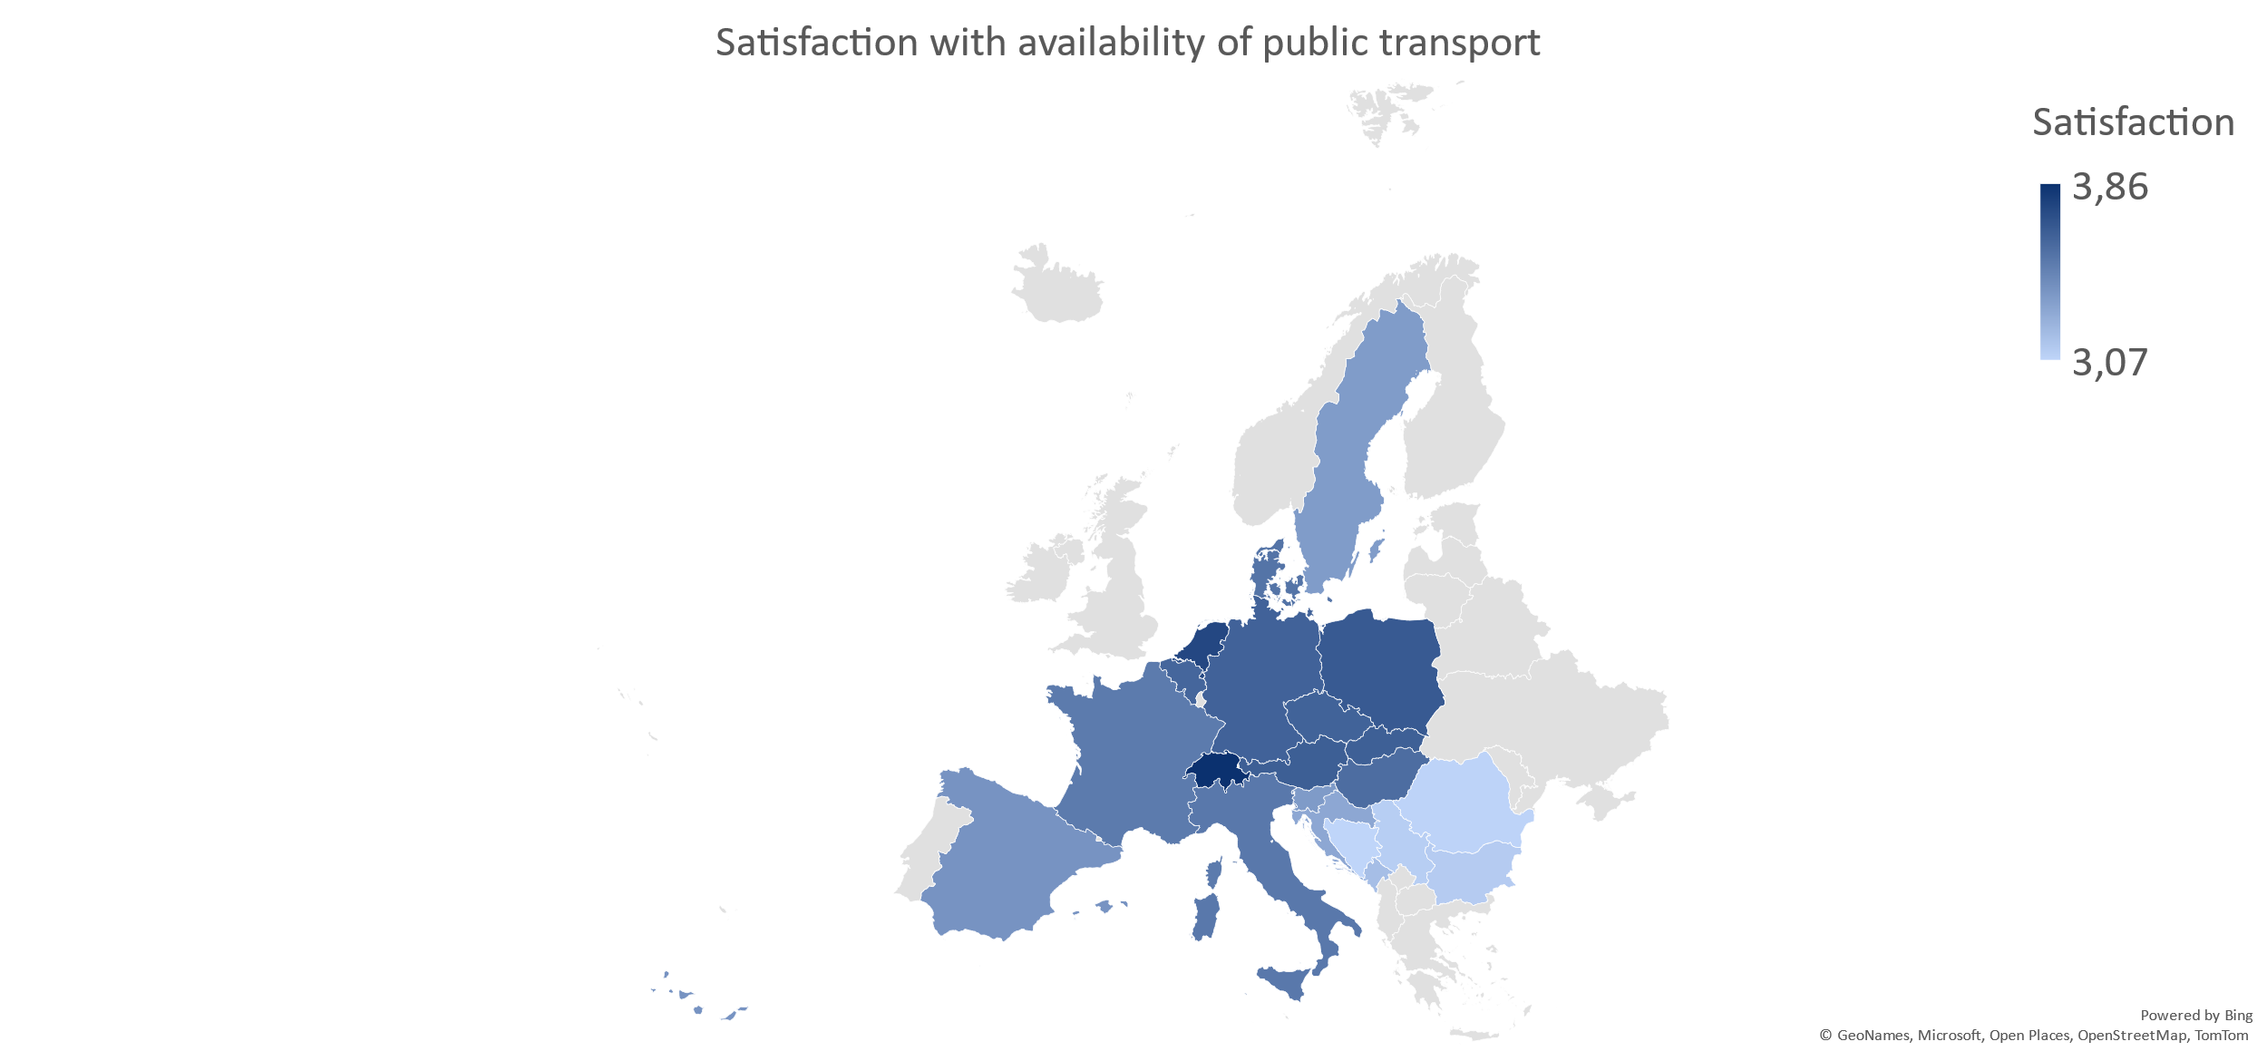

Figure 26: Satisfaction with availability of public transport according to destination of last cycling holiday

The potential for improvement also becomes apparent when looking at the areas where respondents see the most need for improvement: After cycling infrastructure, capacity for bicycle transport in trains/buses and cycling-friendly public transport connections were the most named answers, in the Danube Region together with signage on bicycle routes. The following table shows the 5 most mentioned areas out of a total of 13:

|  |  |
| --- | --- |
| **Ranking of five most important areas needing improvement** | |
| **All answers** | **Danube Region visitors** |
| 1. Cycling infrastructure | 1. Cycling infrastructure |
| **2. Capacity for bicycle transport in trains/busses** | **2. Capacity for bicycle transport in trains/busses** |
| **3. Cycling-friendly public transport connections** | 3. Signage on bicycle routes |
| 4. Signage on bicycle routes | **4. Cycling-friendly public transport connections** |
| 5. Safe bicycle parking | 5. Safe bicycle parking |

Table 11: 5 main areas needing improvement (out of 13)

### Satisfaction with specific aspects of public transport stops

Low ratings for capacity of bicycle transport on trains/buses and availability of secure bike parking at stations

Looking at the satisfaction with specific aspects of public transport stops, there are no big differences in the answers between the subsamples of visitors of the Danube Region and those who spent their last cycling holiday outside the region, except for cleanliness of stations and availability and cleanliness of restrooms, which were both graded noticeably better outside the Danube Region than inside.

Aspects that were rated particularly low in both groups were the capacity for bicycle transport on trains/busses and the availability of secure bike parking. Other points which were rated low did only receive a few ratings in total and were not used by a majority of respondents, like charging options for e-bikes/pedelecs (not used by 86% of respondents) or bike-sharing services (availability, convenience of use etc., not used by 83% of respondents). Comparing this to other aspects, for example only 27% of respondents stated that they did not use the gastronomic offer at stations.

Figure 27: Satisfaction with specific aspects of public transport stops (scale from 1 – not satisfied at all to 5 – extremely satisfied)

**APPENDICES**

**Appendix 1: Questionnaire**

Introduction Text

Do you like cycling? Have you ever cycled during your holidays? Then fill out this survey! Your anonymous feedback about your cycling experience and habits will help us improve cycling tourism, especially when combined with public transport. Thanks to your answers to this 10-minute survey, we will better understand cyclists’ needs, especially in the Danube Region. The survey includes a special focus on public transport as a sustainable addition to cycling for longer distances.  The survey is conducted by the European Cyclists’ Federation, manager of the EuroVelo initiative. It has been commissioned by the Danube Office Ulm/Neu-Ulm as part of the EU-co-funded Interreg Danube Region project Active2Public Transport. All answers will be used confidentially and for aggregated analysis.

Demographics

Q1: What is your gender?

* Female
* Male
* Diverse/non-binary/no gender/other __________

Q2: What is your age?

* 16 - 24 years
* 25 - 44 years
* 45 - 64 years
* 65 years or older

Q3: How often do you cycle?

* At least once a day
* A few times a week
* A few times a month or less often
* Never
* Don’t know

Q4: Which type of cyclist are you? [multiple answers]

* Mobility: I cycle for (daily) transport purposes.
* Sport: I cycle for physical activity.
* Leisure: I cycle in my free time, to enjoy landscapes, cultural or gastronomic visits etc.
* Tourist: I cycle during my vacation.
* Observer: I like cycling, but I do not cycle often.

Q5: Have you ever been on a cycling holiday? (cycling holiday: holiday away from home, with at least one overnight stay, which involves cycling as main activity during the holiday)

* Yes
* No

Q6: Have you used public transport during one or more of your last 3 leisure cycling trips?

* Yes
* No
* I don’t remember.

Q7: The next questions are related to your experience with public transport during (one of) your last 3 leisure cycling trips

Q8: Which sources of information on public transport did you use for your leisure cycling trip? [multiple answers]

* Online travel planner (desktop computer)
* Mobile apps/websites
* Machines at stations/stops
* Timetables at the station
* Information points/service staff
* I don’t remember
* Other __________

Q9: How useful did you find the digital tools (mobile apps, websites, machines with real-time information etc.) to combine your leisure cycling trip with public transport?

Q10: Did you take your bike with you on public transport?

* Yes
* No
* I don’t remember

Q11: How satisfied were you with taking your bike on public transport?

Q12: How satisfied were you with the following services at train/tram/bus stations?

|  |  |  |  |  |  |  |  |
| --- | --- | --- | --- | --- | --- | --- | --- |
|  | 1: not satisfied at all | 2 | 3 | 4 | 5: extremely satisfied | not available | did not use |
| Safe and barrier-free access for cyclists | ❏ | ❏ | ❏ | ❏ | ❏ | ❏ | ❏ |
| Information on bicycle transport | ❏ | ❏ | ❏ | ❏ | ❏ | ❏ | ❏ |
| Availability of secure bicycle parking | ❏ | ❏ | ❏ | ❏ | ❏ | ❏ | ❏ |
| Guidance system/signage at the station | ❏ | ❏ | ❏ | ❏ | ❏ | ❏ | ❏ |
| Capacity for bicycle transport on trains/busses | ❏ | ❏ | ❏ | ❏ | ❏ | ❏ | ❏ |
| Ticketing for bicycle transport on trains/busses | ❏ | ❏ | ❏ | ❏ | ❏ | ❏ | ❏ |
| Bike-sharing services (availability, convenience of use etc.) | ❏ | ❏ | ❏ | ❏ | ❏ | ❏ | ❏ |
| Charging options for e-bikes/pedelecs | ❏ | ❏ | ❏ | ❏ | ❏ | ❏ | ❏ |
| Cleanliness of stations | ❏ | ❏ | ❏ | ❏ | ❏ | ❏ | ❏ |
| Restrooms (availability, cleanliness etc.) | ❏ | ❏ | ❏ | ❏ | ❏ | ❏ | ❏ |
| Gastronomic offer (availability, variety, price etc.) | ❏ | ❏ | ❏ | ❏ | ❏ | ❏ | ❏ |

Q13: How satisfied were you overall with your experience at train/tram/bus stations?

Q14: You have stated that you have been on a cycling holiday already. Why did you opt for this type of holiday? [up to three answers possible]

* Seeing & experiencing more of your destination
* Being active during your holiday
* Exploring routes and landscapes only accessible by bike
* Travelling in an environmentally friendly and/or climate-conscious way
* Improving your health
* Travelling budget-friendly
* Flexibility of choosing your own travel routes &#43; times
* Other __________

Q15: Have you ever been on a cycling holiday in the Danube Region?

* Yes
* No

Q16: What was the destination of your last cycling holiday? [multiple answers possible in case of cross-border tour]

* Albania
* Andorra
* Armenia
* Austria
* Azerbaijan
* Belarus
* Belgium
* Bosnia and Herzegovina
* Bulgaria
* Croatia
* Cyprus
* Czechia
* Denmark
* Estonia
* Finland
* France
* Georgia
* Germany
* Greece
* Hungary
* Iceland
* Ireland
* Italy
* Kazakhstan
* Kosovo
* Latvia
* Liechtenstein
* Lithuania
* Luxembourg
* Macedonia (FYROM)
* Malta
* Moldova
* Monaco
* Montenegro
* Netherlands
* Norway
* Poland
* Portugal
* Romania
* Russia
* San Marino
* Serbia
* Slovakia
* Slovenia
* Spain
* Sweden
* Switzerland
* Türkiye
* Ukraine
* United Kingdom (UK)
* Vatican City (Holy See)
* Other __________

Q17: Which region(s) in Germany did you visit? [multiple answers possible]

* Allgäu
* Bodensee
* Chiemsee-Chiemgau
* Bayerisch-Schwaben
* Bayerischer Wald
* Ammersee-Lech
* Berchtesgadener Land
* Naturpark Altmühltal
* Tegernsee-Schliersee
* Inn-Salzach
* Fränkische Schweiz
* Rhön
* Spessart-Mainland
* Fränkisches Weinland
* Oberpfälzer Wald
* Neckar-Alb
* Schwarzwald
* Schwäbische Alb
* Hohenlohe
* Odenwald
* Heilbronner Land
* Kraichgau-Stromberg
* Kurpfalz
* Taubertal
* Other __________

Q18: Which region(s) in Slovakia did you visit? [multiple answers possible]

* Podunajsko
* Záhorie
* Malé Karpaty
* Považie
* Kysuce
* Liptov
* Vysoké Tatry
* Spiš
* Stredné Slovensko
* Zemplín - Tokaj
* Other

Q19: Which region(s) in Slovenia did you visit? [multiple answers possible]

* Coastal region
* Alpine region
* Karst region
* Styria
* South East region
* Central Slovenia (Ljubljana and surroundings)
* Other __________

Q20: Which region(s) in Serbia did you visit? [multiple answers possible]

* Podunavlje - EuroVelo 6
* Vojvodina
* Fruška gora
* Tara Golija
* Divčibare
* Javor
* Sjenica - Pešter
* Zlatibor
* Drina
* Sava - Srem
* Šumadija
* Other __________

Q21: Which region(s) in Hungary did you visit? [multiple answers possible]

* Szigetköz
* Alpokalja
* Őrség
* Dél-Zala
* Balaton
* Vértes,Velencei hg.
* Pilis, Visegrádi hg.
* Börzsöny, Dunakanyar
* Zempléni-hg.
* Felső-Tisza-vidék
* Tisza-tó, Hortobágy
* Körösök-völgye
* Ráckevei-Soroksári Duna
* Közép-Duna mente
* Villányi-hg.
* Zselic
* Bakony
* Gerecse, Budai-hg.
* Belső-Nógrád Karancs-Medves-vidék, Kelet-Cserhát Mátra
* Dél-Gömör
* Bükk
* Aggteleki-karszt
* Mecsek
* Dél-Alföld
* Other __________

Q22: Which region(s) in Romania did you visit? [multiple answers possible]

* Dobrogea
* Moldova
* Transilvania
* Bucovina
* Crișana
* Maramureș
* Banat
* Muntenia
* Oltenia
* Other __________

Q23: Which region(s) in Croatia did you visit? [multiple answers possible]

* Zagorje i prigorje
* Plitvice, Slunj, Karlovac
* Istria
* Kvarner
* Lika
* Zagreb, Medvednica, Žumberak
* Medimurje
* Podravina
* Slavonija, Srijem i Baranja
* Dalmacija
* Gorski kotar
* Banovina
* Moslavina
* Other __________

Q24: Which region(s) in Austria did you visit? [multiple answers possible]

* Donauradweg (Danube River Cycling Route) - EuroVelo 6
* Murradweg (River Mur Cycling Route)
* Innradweg (Inn River Cycling Route)
* Drauradweg (Drava River Cycling Route)
* Tauernradweg (Tauern Alps Cycling Route)
* Alpe Adria Radweg (Alps Adriatic Sea Cycling Route)
* Ennsradweg (Enns River Cycling Route)
* Via Claudia Augusta Radweg (Alps Cycling Route Germany - Tirol, AT - Italy)
* EuroVelo 9 - Baltic – Adriatic (AT Wien - Hartberg - Fürstenfeld - Bad Radkersburg)
* Neusiedler See Radweg (Lake Neusiedl Cycling Route)
* Salzkammergut Radweg (Salzkammergut Lakes Cycling Route)
* EuroVelo 13 - Iron-Curtain-Trail (via Gmünd - Retz - Marchegg)
* Other __________

Q25: Which region(s) in Czechia did you visit? [multiple answers possible]

* Karlovy Vary Region
* Pilsen Region
* Ústí nad Labem Region
* Central Bohemian Region
* Prague
* South Bohemian Region
* Liberec Region
* Hradec Králové Region
* Pardubice Region
* Vysočina Region
* Olomouc Region
* South Moravian Region
* Moravian-Silesian Region
* Zlín Region
* Other __________

Q26: Do you plan to go on cycling holidays in the Danube Region in the future?

* Yes
* No
* Maybe/I don’t know.

Q27: Do you plan to use public transport on your future cycling holiday in the Danube Region?

* Yes
* No
* Maybe/I don’t know.

Q28: How long was your last cycling holiday [number of nights]?

Q29: How did you plan your cycling holiday? [multiple answers]

* Internet research
* Guidebooks
* Recommendations from friends/family/colleagues etc.
* Recommendations on social media
* Mobile applications
* Travel agency
* Tour operator
* Tourist information
* Tourism or cycling fairs
* Other __________

Q30: Which mobile application did you use to plan the itinerary of your cycling holiday? [multiple answers]

* Google Maps
* Komoot
* RideWithGPS
* EuroVelo Mobile App
* Organic Maps
* Mapy.cz
* Geovelo
* Outdooractive
* Strava
* Open Street Maps
* Apps of public transport operators
* Apps of regional tourist boards
* Other __________

Q31: Which route type do you prefer for your cycling holidays?

* Linear routes (not coming back to the starting point, changing accommodation)
* Loop-shaped routes (coming back to the starting point at the end of the trip, changing accommodation)
* Star-shaped routes (coming back to the starting point every day of the trip, not changing accommodation)
* No preference

Q32: Please rate each of the following criteria according to their importance when planning your cycling holiday

* Dedicated cycling infrastructure available (e.g. being separated from motorised traffic)
* GPX tracks of the route easily accessible online
* Offer of cycling-friendly services along the route
* Accessibility of the destination by public transport
* Price of the trip
* Charging options for e-bikes/pedelecs
* Possibility to carry my bicycle on public transport
* Availability of bike rental services

During your trip

Q33: For your last cycling holiday, did you use your own bike or a rented bike?

* My own bike
* A rented bike

Q34: During your last cycling holiday, did you use an e-bike/pedelec?

* Yes
* No

Q35: Which type of bicycle or e-bike/pedelec did you use on your last cycling holiday?

* Trekking bike
* City-bike
* Road bike
* Mountain bike
* Gravel bike
* Folding bike
* Cargo bike
* Tandem
* Adapted bike (Tricycle for example)
* Recumbent Bicycle
* Other type of bicycle

Q36: Which modes of transport did you use for traveling to/from the starting/end point of your last cycling holiday? [multiple answers]

* Bicycle (Cycling to/from your destination and/or to/from your home)
* Railway
* Long-distance bus
* Local public transport
* Car
* Caravan/Campervan/Motorhome etc.
* Airplane
* Other __________

Q37: How important is each of the following criteria when choosing your mode of transport to reach the starting/end point of your cycling holiday?

* Price
* Duration of the journey
* Convenience/comfort
* Sustainability
* Cancellation option

Q38: Which sources of information on public transport did you use to plan the journey to/from the starting/end point of your cycling holiday? [multiple answers]

* Online travel planner (desktop computer)
* Mobile application
* Machines at the station
* Counters at the station
* Travel agency
* I don't remember
* Other __________

Q39: How useful did you find the digital tools (mobile apps, websites, machines with real-time information etc.) to combine your cycling holiday with public transport?

Q40: How satisfied were you overall with your last cycling holiday?

Q41: How satisfied were you with the following aspects during your cycling holiday?

|  |  |  |  |  |  |  |  |
| --- | --- | --- | --- | --- | --- | --- | --- |
|  | 1: not satisfied at all | 2 | 3 | 4 | 5: extremely satisfied | not available | did not use |
| Cycling infrastructure (e.g. separation from motorised traffic) | ❏ | ❏ | ❏ | ❏ | ❏ | ❏ | ❏ |
| Safe bicycle parking | ❏ | ❏ | ❏ | ❏ | ❏ | ❏ | ❏ |
| Signage on cycle routes | ❏ | ❏ | ❏ | ❏ | ❏ | ❏ | ❏ |
| Bicycle service/repair stations | ❏ | ❏ | ❏ | ❏ | ❏ | ❏ | ❏ |
| Public restrooms | ❏ | ❏ | ❏ | ❏ | ❏ | ❏ | ❏ |
| Gastronomic offer | ❏ | ❏ | ❏ | ❏ | ❏ | ❏ | ❏ |
| Resting areas | ❏ | ❏ | ❏ | ❏ | ❏ | ❏ | ❏ |
| Accommodation options | ❏ | ❏ | ❏ | ❏ | ❏ | ❏ | ❏ |
| Charging options for e-bikes/pedelecs | ❏ | ❏ | ❏ | ❏ | ❏ | ❏ | ❏ |
| Luggage lockers | ❏ | ❏ | ❏ | ❏ | ❏ | ❏ | ❏ |
| Shuttle services for luggage | ❏ | ❏ | ❏ | ❏ | ❏ | ❏ | ❏ |
| Availability of public transport | ❏ | ❏ | ❏ | ❏ | ❏ | ❏ | ❏ |
| Availability of bike-rental services | ❏ | ❏ | ❏ | ❏ | ❏ | ❏ | ❏ |

Q42: Did you use public transport during your cycling holiday (apart from the journey to/from your starting/end point)?

* Yes
* No
* I don't remember

Q43: Which sources of information on public transport did you use during your cycle holiday? [multiple answers]

* Mobile apps/websites
* Ticket machines at stations/stops
* Machines at stations
* Timetables at the station
* Information points/service staff
* I don’t remember
* Other __________

Q44: How useful did you find the digital tools (mobile apps, websites, machines with real-time information etc.) to combine your cycling holiday with public transport?

The next questions are related to your experience with public transport, either on the journey to/from your starting/end point or during your cycling holiday.

Q45: Did you take your bike with you on public transport?

* Yes
* No
* I don’t remember

Q46: How satisfied were you with taking your bike on public transport?

Q47: How satisfied were you with the following services at train/tram/bus stations?

|  |  |  |  |  |  |  |  |
| --- | --- | --- | --- | --- | --- | --- | --- |
|  | 1: not satisfied at all | 2 | 3 | 4 | 5: extremely satisfied | not available | did not use |
| Safe and barrier-free access for cyclists | ❏ | ❏ | ❏ | ❏ | ❏ | ❏ | ❏ |
| Information on bicycle transport | ❏ | ❏ | ❏ | ❏ | ❏ | ❏ | ❏ |
| Availability of secure bicycle parking | ❏ | ❏ | ❏ | ❏ | ❏ | ❏ | ❏ |
| Guidance system/signage at the station | ❏ | ❏ | ❏ | ❏ | ❏ | ❏ | ❏ |
| Capacity for bicycle transport on trains/busses | ❏ | ❏ | ❏ | ❏ | ❏ | ❏ | ❏ |
| Ticketing for bicycle transport on trains/busses | ❏ | ❏ | ❏ | ❏ | ❏ | ❏ | ❏ |
| Bike-sharing services (availability, convenience of use etc.) | ❏ | ❏ | ❏ | ❏ | ❏ | ❏ | ❏ |
| Charging options for e-bikes/pedelecs | ❏ | ❏ | ❏ | ❏ | ❏ | ❏ | ❏ |
| Cleanliness of stations | ❏ | ❏ | ❏ | ❏ | ❏ | ❏ | ❏ |
| Restrooms (availability, cleanliness etc.) | ❏ | ❏ | ❏ | ❏ | ❏ | ❏ | ❏ |
| Gastronomic offer (availability, variety, price etc.) | ❏ | ❏ | ❏ | ❏ | ❏ | ❏ | ❏ |

Q48: How satisfied were you with your overall experience with train/tram/bus stations?

Q49: Why did you not use public transport? [up to 3 answers]

* There were no public transport connections available
* It was too expensive
* I would have had to change too many times
* It would have taken too long
* I could not find information
* Bicycle transport was not available
* Other

After your trip

Q50: How much do you cycle in your daily life after going on a cycling holiday?

* I cycle more in my daily life now than before going on a cycling holiday.
* I cycle less in my daily life now than before going on a cycling holiday.
* I cycle the same amount in my daily life now as before going on a cycling holiday.
* I don’t know.

Q51: Based on your experience during your last cycling holiday, which of the following areas need improvement? [make a ranking from highest to lowest priority]

* Cycling infrastructure (separation from motorised traffic, surface…) __________
* Signage on bicycle routes __________
* Safe bicycle parking __________
* Cycling-friendly public transport connections __________
* Bicycle service/repair stations __________
* Public restrooms __________
* Gastronomic offer __________
* Resting areas __________
* Accommodation options __________
* Charging options for e-bikes __________
* Shuttle services for luggage __________
* Bike rental services __________
* Capacity for bicycle transport in trains/busses __________

Q52: Do you plan to go on cycling holidays again in the future?

* Yes
* No
* Maybe/I don’t know.

Q53: Do you plan to use public transport on your next cycle holiday?

* Yes
* No
* Maybe/I don’t know.

Q54: You have stated that you have not been on a cycling holiday yet. Could you give us some reasons why not? [multiple answers]

* I couldn’t find any suitable accommodation.
* I find cycling trips too dangerous.
* A cycling holiday is too expensive for me.
* I didn't find any attractive long-distance cycle routes.
* The weather was not suitable.
* Arriving and departing by bike is complicated.
* I didn't have a suitable travel companion.
* I don't have the right equipment.
* A cycling trip is physically too demanding for me.
* Other __________

Q55: Could you imagine going on a cycling holiday during the next years?

* Yes
* No
* Maybe/I don’t know

Q56: Would you have any additional comments to share with us on your cycling holiday experience in the Danube Region (also for cycling holidays other than your last one)?

Q57: Would you have any additional comments to share with us?